RESOLUTION NO.__________

RE: CERTIFICATE OF APPROPRIATENESS UNDER THE
PROVISIONS OF THE ACT OF THE PENNSYLVANIA
LEGISLATURE 1961, JUNE 13, P.L. 282 (53
SECTION 8004) AND BETHLEHEM ORDINANCE NO.
3952 AS AMENDED.

WHEREAS, it is proposed to change the location of a previously approved sign from the north wall to the west wall at 459 Old York Road – Luckenbach Mill.

NOW, THEREFORE, BE IT RESOLVED by the Council of the City of Bethlehem that a Certificate of Appropriateness is hereby granted for the proposal.

Sponsored by: (s)

(s)

ADOPTED BY COUNCIL THIS DAY OF

(s)
President of Council

ATTEST:

(s)
City Clerk

HISTORICAL & ARCHITECTURAL REVIEW BOARD

The applicant proposes to change the location of a previously approved sign from the north wall to the west wall at 459 Old York Road – Luckenbach Mill.
APPLICATION #6:

Central Moravian Church
561 E. Market St.
Bethlehem, PA 18018
OWNER:

__________________________________________________________________

The Board upon motion by Marsha Fritz and seconded by Connie Glagola adopted the proposal that City Council issue a Certificate of Appropriateness for the following:

1. Sign to be moved from the north wall to the west wall.

2. The sign will be mounted perpendicular to the wall and 10’ above grade to the
bottom of the sign.

3. The motion was unanimously approved.
__________________________________________________________________________

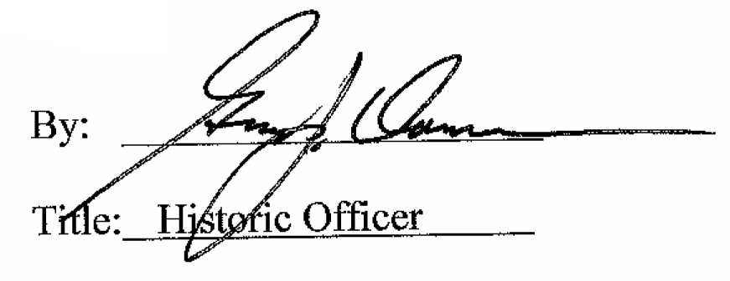

Date of Meeting: July 6, 2016

